

Travel and the country house: places, cultures and practices

University of Northampton, 15-16 September 2014

Keynote speakers include: Roey Sweet, University of Leicester, and Margot Finn, UCL

Travel has long played a vital role in shaping the country house, opening up horizons and exposing both house and owner to a variety of external influences. Travel impacted upon values, tastes, material culture and money, and helped to articulate the flow of ideas, information, goods and capital. The importance of the Grand Tour and Empire to the country house has long been recognised, but domestic tourism and travel for more mundane purposes – to visit family or friends, engage in political life or go to town – were also significant. In this conference, we wish to explore a wide range of travel experiences and consider how these impacted on the country house. How were travel choices made and how were impacts articulated? How did new influences mesh with existing tastes and goods? What impact did its status as a place to visit have upon the country house? And how do we communicate the importance of travel to those visiting country houses today?

This conference addresses these questions and others, drawing together research from Sweden, Hungary, the Netherlands and Ireland as well as all corners of England. It thus offers a comparative perspective on the relationship between travel and the country house, and an opportunity for academics, curators and managers to discuss the ways in which travel continues to shape the ways in which country houses are interpreted, presented and experienced.

For more details and a booking form, contact Prof Jon Stobart: jon.stobart@northampton.ac.uk or visit: http://consumptionandthecountryhouse.ning.com/.
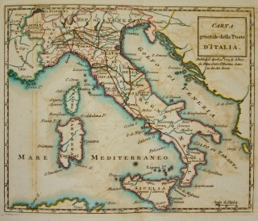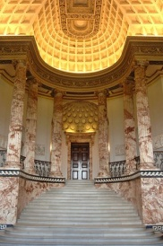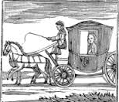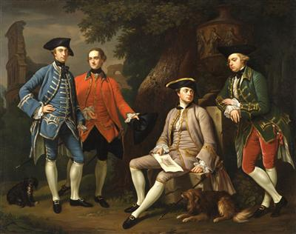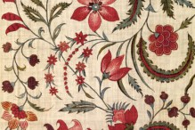

Travel and the country house: places, cultures and practices

Northampton, 15-16th September 2014-06-20

Draft Programme

Monday 15th September
10.00-10.40 Registration and coffee
10.40-10.45 Welcome and introduction
10.45-11.45 Keynote: ‘The Italian Grand Tour and the 18th century country house’, Roey Sweet (University of Leicester)
11.45-13.00 Session 1: The practicalities and pleasures of travel
‘Visiting London for business and pleasure in the years 1599-1623: on the road (and the Thames) with William Cavendish, 1st. Earl of Cavendish’ - Peter Edwards (University of Roehampton)
‘Travelling for Pleasure – carriages and the country house’ - Lizzy Jamieson (Independent Scholar)
‘“Wintering in the ‘shires”: Foxhunting and travel’ – Mandy de Belin (University of Leicester)
13.00-14.00 Lunch
14.00-15.45 Session 2: European travel, networks and influences
‘The Grand Tour and Episcopal domesticity: the case of Martin Benson, Bishop of Gloucester (1735-52)’ - Michael Ashby (University of Cambridge)
‘“Antiquity mad”: the Earl Bishop and the translation of continental style in an Irish context’ – Rebecca Campion (National University of Ireland at Maynooth)
‘Centre and periphery: the world brought to the ironmasters’ mansions’ – Marie Steinrud (Stockholm University)
‘The English Rothschild family and their country houses: a distinctive style’ – Nicola Pickering (affiliation?)
15.45-16.15 Tea & coffee
16.15-18.00 Session 3: Views of England from overseas travellers
‘The English country house as (proto) museum: Dutch travel accounts explored (1677-1750)’ – Hanneke Ronnes (University of Amsterdam)
‘“... enjoying country life to the full – only the English know how to do that!”: Appreciation of the British country house by Hungarian aristocratic travellers’ - Kristof Fatsar (Corvinus University of Budapest)
‘Stourhead: all roads lead to Rome – and back again’ – John Harrison (Open University)
‘A Dutch view on the English Country House and landscape garden’ – Helen Bremer (University of Leiden)
18.30-19.30 Reception
19.30 Dinner
Tuesday 16th September
9.30-10.45 Session 4: The mobile house
‘Manors, towns and spas. A household on the move in the late 18th century Sweden’ – Goran Ulvang (University of Uppsala)
‘The travels of an aristocratic family in the early 19th century: the Braybrookes of Audley End, Essex’ – Andrew Hann (English Heritage)
‘Moving households – problems, choices and new possibilities facing the country-house family in the 1820s and 1830s’ – Pamela Sambrook (Independent Scholar)
10.45-11.15 Tea and coffee
11.15-1.00 Session 5: Travel, tourism and guides
'Domestic tourism, the country house, and the making of respectability in the travel journals of Caroline Lybbe Powys’ – Freya Gowrley (University of Edinburgh)
‘Country house visiting and improvement at Herriard House in Hampshire, 1794-1821’ – Nicky Pink (Independent Scholar)
‘Arthur Young’s Tours: architecture, painting, sculpture, and the art of adorning grounds’ – Jocelyn Anderson (The Courtauld Institute of Art)
‘The representation of the country house in individual books and guides 1720-1845’ – Paula Riddy (University of Sussex)
1.00-2.00 Lunch
2.00-3.00 Keynote 2: Duleep Singh and the Country House Tradition: Making and Unmaking the Victorian Global Home: Prof Margot Finn (UCL)
3.00-4.15 Session 6: Looking beyond Europe
‘Travel to the East- and West-Indies and Groningen country house culture in the 18th Century ‘ – Yme Kuiper (University of Groningen)
‘Appuldurcombe House and the ‘Museum Worsleyanum’: Sir Richard Worsley’s forgotten collection’ – Abigail Coppins (Independent Scholar)
‘ Diaries, decoration and design: the Courtaulds’ travels and the effects on Eltham Palace’ – Annie Kemkaran-Smith (English Heritage)
4.15-4.30 Closing comments and discussion

