TOMASSO BROTHERS FINE ART
at TEFAF Maastricht, 13-22 March 2015, Stand 165

Recognised as expert in important European sculpture, Tomasso Brothers Fine Art also specialises in Old Master paintings. At TEFAF 2015 the gallery unveils an exquisite pair of portrait miniatures by one of the most sought-after masters of the genre Jean-Etienne Liotard (1702-1789) depicting Princes Charles Edward Stuart (1720-1788) and Henry Benedict Stuart (1725-1807), last in the lineage of Stuart Kings in Scotland and England. The asking price for these miniature masterpieces is £275,000.

One of the most romantic figures in British history, celebrated in folklore as Bonnie Prince Charlie, Prince Charles Edward Stuart the led the final Jacobite Rebellion of 1745 that was to end in defeat on the battle field of Culloden.

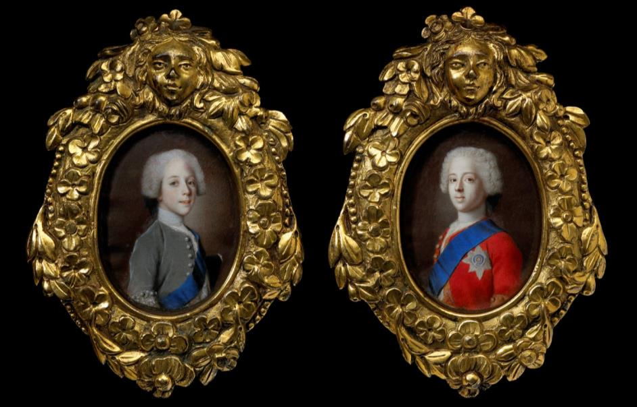
Left: Prince Henry Benedict Stuart 1725-1807 and Right: Prince Charles Edward Stuart 1720-1788
by Jean-Etienne Liotard c1736-8, watercolour and gouache on vellum, 7.4cm high by 5.5cm wide (excluding frame)

Born to French parents in Geneva, Jean-Etienne Liotard trained in Paris under the miniaturist and printmaker Jean-Baptiste Massé. While in Rome between 1736 and 1738, Liotard was commissioned by the exiled ‘Old Pretender’ James Edward Stuart (1688-1766) “the king across the water”, to paint portraits of his young sons Princes Charles and Henry. Powerfully compelling, imagery of the Stuart royal family was easily dispatched abroad as portraits miniatures, engravings and prints, to garner loyalty and raise funds for the Jacobite cause to re-claim the throne of England. These particular miniatures may have been part of a group of three Stuart portraits sent to Vienna to be seen by Empress Elizabeth, wife of the Holy Roman Emperor Charles VI.
The attribution of these portraits is confirmed by Professor Marcel Roethlisberger, author of the definitive monograph on Jean-Etienne Liotard; they are illustrated in his 2008 catalogue. In addition to the evidence that miniatures were sent to Empress Elizabeth in Vienna, a miniature of Prince Charles is recorded as having been sent to Dorotea, Dowager Duchess of Parma and mother of the Queen of Spain. Other miniatures of the Stuarts were sent to England and France.

These extraordinary works will be a highlight at Tomasso Brothers Fine Art, stand 165, TEFAF 2015, and will be offered for sale priced at £275,000. The fair, which is the world’s leading art and antiques event, takes place at the Maastricht Exhibition and Congress Centre (MECC) from 13-22 March 2015.

Based at Bardon Hall, Leeds, Tomasso Brothers Fine Art was established in 1993 and opened their London gallery in St James’s in 2013. Dino and Raffaello are recognised internationally for specialising in important European sculpture from the early Renaissance to the Neoclassical periods with a particular knowledge of European Renaissance bronzes. They have promoted and supported, through loans and exhibitions, major international institutions and were one of the sponsors of the landmark show Bronze at the Royal Academy of Arts, London, 2012. Significant sales have been made to some of the world’s most prestigious museums, including the Bode Museum, Berlin; The Liechtenstein Collection, and the Kunsthistorisches Museum, Vienna; the Metropolitan Museum of Art, New York; the Yale Center for British Art and the Art Institute of Chicago.

www.tomassobrothers.co.uk
NOTES TO EDITORS:

During TEFAF 2015 exactly 300 years will be marked on 14th March 1715 when the ‘Old Pretender’ James Edward Stuart (1688-1766) set the first Jacobite Rebellion in motion by writing to Pope Clement XI appealing for help in his cause.

After the failure of this uprising, James Edward Stuart went in exile with his Court to Rome where his elder son Charles Edward Stuart was born in 1720. On 23 July 1745, in an attempt to restore his father to the throne, the young prince landed in Scotland, raising his standard and calling the clans to Glenfinnan. The Jacobite army grew in size as it marched across Scotland, and achieved a minor victory at the Battle of Prestonpans, just outside Edinburgh, in September of that year. Emboldened by this victory, by December the army had advanced to Derby in the heart of England.

However, the promised support of funds and fresh troops from France never materialised and, compounded by a severe winter, it was an exhausted and demoralised army that retreated north back into Scotland to face the Duke of Cumberland’s significantly fresher and larger Hanoverian army on Culloden Moor. The battle was little less than a slaughter for the Jacobites and the clans would never rise again. The prince managed to flee to France after being hunted through the western Highlands (reputedly on one occasion being disguised as a maid by Flora Macdonald when she rescued him by boat to the island of Skye). He lived out his days in exile.

The miniature of Charles Edward presented here shows the eighteen year old prince, before he undertook his military efforts, wearing an embroidered red velvet coat, with the blue sash of the
Order of the Garter. His expression is solemn as he looks out towards the viewer, possibly a reminder of the unhappy fate of his ancestors since the times of King Charles I. His younger brother, Prince Henry Benedict Stuart, depicted in the pendant, wears a silvery green velvet coat and richly embroidered cuffs. His youth is betrayed by the softness of childhood still lingering upon his delicate features.

Prince Henry, later Cardinal Duke of York, was also born and baptised in Rome, in 1725. After the death of his brother in 1788, he was known by supporters of the Jacobite cause as ‘Henry IX, King of Great Britain, France and Ireland’. In 1745, when hopes of a Stuart restoration ran high, he travelled to France hoping to help his brother, but returned to Rome after having spent several months at Dunkirk with little effect. In 1747, at the age of 22, he received Holy Orders and was ordained a priest, becoming Cardinal-Bishop of Frascati where he founded a seminary, which he endowed with a magnificent library. As a result of the French Revolution, Henry’s property in Frascati was seized and he was reduced to poverty. However, King George III came to his assistance, granting him a life annuity until he was able to return to Frascati in 1800. In return for this kindness, the grateful cardinal bequeathed to the Prince of Wales, later George IV, the crown jewels of James II. Both Charles and Henry Stuart are buried in St. Peter’s, Rome.

Provenance:
Possibly James Francis Edward Stuart, Palazzo Muti, Rome: whence Empress Elizabeth Christine of Brunswick-Wolfenbüttel, wife of the Holy Roman Emperor Charles VI, Vienna, by 1738.
Sir Alfred Chester Beatty, Clonmannon, Ashfrod, Co. Wicklow, Ireland, by 1968.
Private Collection, England.

Published:
Marcel Roethlisberger and Renee Loché, Liotard: Catalogue Sources et Correspondance (Davaco 2008), Vol. 1: pp 257-258; Vol. 2: cat. 46 & 49

Related Literature:
Edward Corp, The King over the Water, portraits of the Stuarts in Exile after 1689 (National Galleries of Scotland, 2001), p.73

Tomasso Brothers Fine Art
Based at Bardon Hall, Leeds, Tomasso Brothers Fine Art was established in 1993 and opened their London gallery in St James’s in 2013. Dino and Raffaello are recognised internationally for specialising in important European sculpture from the early Renaissance to the Neoclassical periods with a particular knowledge of European Renaissance bronzes. They have promoted and supported, through loans and exhibitions, major international institutions and were one of the sponsors of the landmark show Bronze at the Royal Academy of Arts, London, 2012. Significant sales have been made to some of the world’s most prestigious museums, including the Bode Museum, Berlin; The Liechtenstein Collection, and the Kunsthistorisches Museum, Vienna; the Metropolitan Museum of Art, New York; the Yale Center for British Art and the Art Institute of Chicago.

www.tomassobrothers.co.uk

