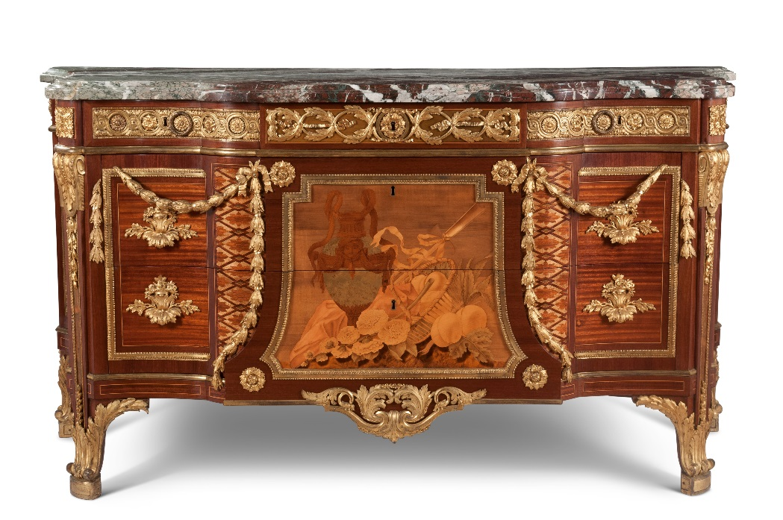

10:00 Registration and Coffee in the Manor Restaurant

10:30 Welcome and Introduction - Christopher Rowell (Furniture Curator, National Trust) and Pippa Shirley (Head of Collection, National Trust / Waddesdon Manor)

10:40 Riesener at Waddesdon Manor
Emily Roy (Curator) & Ulrich Leben (Associate Curator): Introduction to the Exhibition and Research Project
Lindsay Macnaughton (Oxford University Intern): Grammar and the Garde-Meuble de la Couronne: chests of drawers by Jean-Henri Riesener, 1774-1784
Juliet Carey (Senoir Curator): A Newly Discovered Portrait of Riesener
11:30 Riesener at the Wallace Collection
Helen Jacobsen (Head of Curatorial Team, Wallace Collection): The 4th Marquess of Hertford's taste for Riesener, 1840-1870
Jürgen Huber (Senior Conservator, Wallace Collection): Riesener Revealed: Documentation and Observation…The Journey So Far
12:00 Rufus Bird (Deputy Surveyor of The Queen’s Works of Art, Royal Collections Trust): George IV and Riesener
12:15 Yannick Chastang (Independent Conservator): J-H. Riesener’s Floral Marquetry
12:30 Questions and Discussion
13:00 Lunch Break – Opportunity to visit the Manor Shop and Wine Shop
14:30 Bertrand Rondot (Chief Curator, Château de Versailles): Versailles, Riesener’s Palace
14.50 Wolf Burchardt (Furniture Research Curator, National Trust): Continental Furniture in National Trust Houses
15:10 Matthew Hirst (Curator, Woburn Abbey): French and Francophile furniture in the Woburn Abbey collection
15:30 Miriam Schefzyk (PhD candidate, Westfälische Wilhelms-Universität Münster & École Pratique des Hautes Études, Paris): Furniture with Porcelain Plaques at Waddesdon Manor
15:45 Carolyn Sargentson (Senior Lecturer in Art History, University of Sussex): A business model for refinement? Riesener's 1773 commission for Pierre de Fontanieu
16:05 Questions and Discussion
16:30 Tea in the Manor Restaurant
16:45 Entry into House to see the Riesener Exhibition and collections
17:30 Study Day ends with a glass of wine in the Manor Restaurant before departure

To book a place please call the Booking Line on 01296 653226 between 10am and 4pm
The fee for the day is £25 which includes all catering, which can be paid with a Debit or Credit card
Please let us know if you have any dietary requirements

Conference Address:
Waddesdon Manor
Waddesdon
Near Aylesbury
Buckinghamshire
HP18 OJH

Nearest Railway Station is Aylesbury Vale Parkway (5/10 minutes from Waddesdon) – advisable to
pre-book a taxi from this station to Waddesdon Manor
or
Aylesbury Station (10/15 minutes from Waddesdon) – as a rule there are taxi’s outside the station

