The Pleasures of the Historical Imagination:
A Dialogue with John Brewer

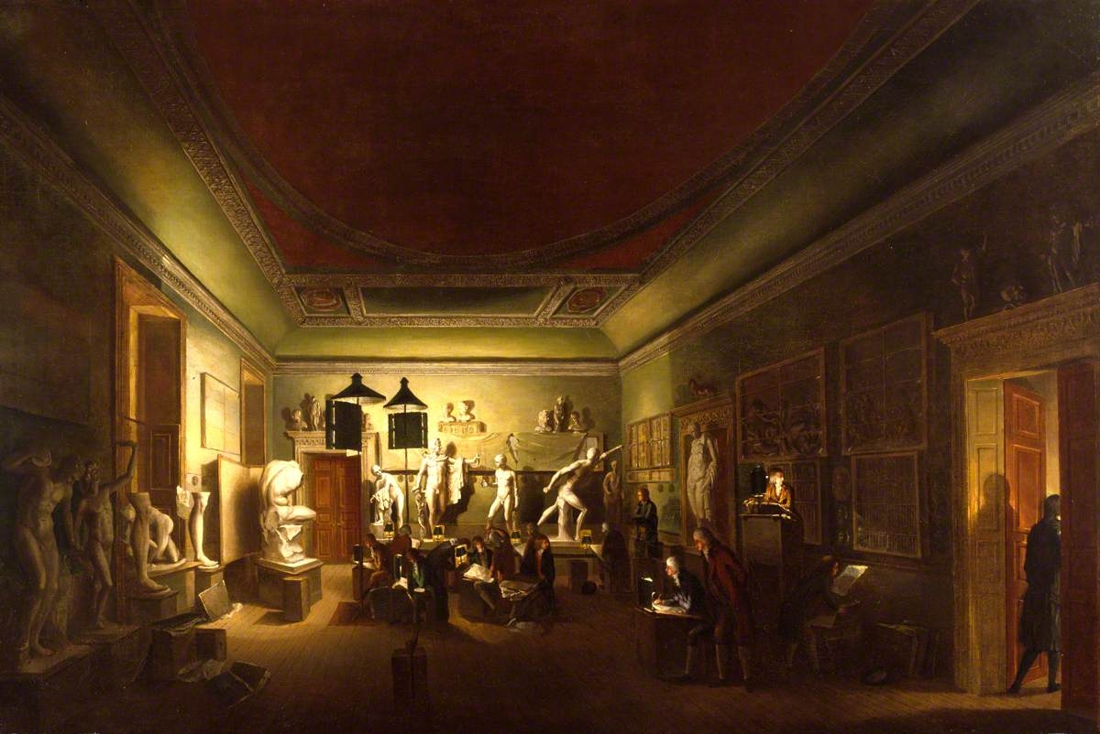

European University Institute
History Department
Villa Salviati

Thursday 22nd and Friday 23rd June 2017

(Sala del Torrino)

John Brewer’s work has cut a wide swathe through political, cultural and economic history. To mark his retirement from teaching, this symposium gathers his former students, interlocutors and friends for an exchange of conversation, discussion, and convivial disagreement, along with an update from John on his current research. These twenty-one papers are not retrospective tributes in the manner of a traditional Festschrift but rather an occasion to report on exciting new findings in the many different fields touched by John’s scholarship.

Organizers: Silvia Sebastiani, Matthew Hunter and Fredrik Albritton Jonsson
Thursday 22nd June 2017

9.30-9.45: Welcome and general introduction

1. Politics and the State
Chair: Eckhart Hellmuth (Ludwig-Maximilians Universität, München)

9.45-10: Joanna Innes (University of Oxford), Britain and the liberation of Europe: Napoleon and after

10-10.15: Paul Monod (Middlebury College), Eighteenth-Century European Politics: Ideology or Culture?

10.15-10.45 Coffee Break

10.45-11.00: Holly Brewer (University of Maryland), Creating a Fashion for Slavery in the Stuart Court(s)

11.00-11.15: Kathleen Wilson (Stony Brook University), Provincializing Britain: English Theatre in an Imperial Public Sphere, or, Modernity at the Margins

11.15-12.15: General Discussion

12.15-14: Lunch

2. Cultural History
Chair: Arthur Legger (University of Amsterdam)

14-14.15: Xenia von Tippelskirch (Humboldt-Universität zu Berlin), Imagining the Italian Renaissance around 1900

14.15-14.30: Sophie Maisonneuve (Université Paris Descartes/IIAC), Collecting recorded music, 1877-2017: from document to experience

14.30-14.45: Alexis Schwarzenbach (Lucerne University), The Great Wave. Katagami, mangas and other Japanese artefacts exported to the West around 1900

14.45-15: Michèle Cohen (UCL Institute of Education, University of London), The Grand Tour: Fashioning ‘Citizens of the World’ or ‘Worthy Citizens of England’?

15-16: General Discussion

16-16.30: Coffee Break

3. Art History and Visual Culture
Chair: Malcolm Baker (University of California Riverside)

16.30-16.45: Davide Lombardo (NYU in Florence), Repressed? Daumier and the massacres of June 1848: Drawings, paintings and lithographs

16.45-17: Flaminia Gennari Santori (Gallerie Nazionali d’Arte Antica di Palazzo Barberini e Palazzo Corsini), “Your Reader is a Martian who understands Everything”: Readers, Viewers and Visitors, Past and Present

17-17.15: Mark Hallett (Paul Mellon Centre), The War of the Portraitists: Artistic Competition and the Dynamics of Exhibition Culture in Georgian London

17.15-17.30: Matthew C. Hunter (McGill University), Thick Slicing: Frederic Edwin Church’s Actuarial Imagination

17.30-18.30: General Discussion

Friday 23rd June 2017

4. Intellectual History and History of Science
Chair: Lawrence Klein (Unversity of Cambridge)

10-10.15: Silvia Sebastiani (EHESS, Paris), At tea with Madame Chimpanzee: a “société de spectacle” in 1730s London

10.15-30: Jan Albers (Independent Writer and Museum Consultant), “I Don’t Like History, but Do You Know What Happened Here?” Writing a Cultural History of the Landscape

10.30-11: Coffee Break

11-11.15: Alexander Geppert (NYU), The Pleasures of the Imagination in Space, or: the Alien Contact Phenomenon

11.15-11.30: Nick Wilding (Georgia State University), Forging the Moon

11.30-12.30: General Discussion

12.30-14: Lunch

5. Consumption and Economic History
Chair: Laurence Fontaine (CNRS)

14-14.15: Fredrik Albritton Jonsson (The University of Chicago), Anthropocene History

14.15-14.30: John Styles (University of Hertfordshire), Industrial Revolution: from production to consumption, and back again’

14.30-14.45: Dawn Lyon (University of Kent), What is a fish worth? Sensory knowledge, labour and the production of value at Billingsgate fish market

14.45-15: Frank Trentmann (Birkbeck, University of London), Material Histories: Scales, Objects and Networks

15-16: General Discussion

16-16.30: Coffee Break

16.30-17: John Brewer, Final remarks and new projects

17-17.30: Final discussion

Abstracts

1. Politics and the State

- Joanna Innes (University of Oxford), Britain and the liberation of Europe: Napoleon and after
During the wars against Napoleon, Britain (and her allies) employed a rhetoric of 'liberation' to describe what they aimed to achieve, and did ultimately achieve. Other propositions spun off this rhetoric, thus, for example, the idea that peoples stood to gain extra rights if they liberated themselves. This rhetoric provided terrain for debate, in Britain and elsewhere, during and after the wars. Although this rhetoric and its uses have attracted significant attention in a German context (where the notion that these were 'wars of liberation' has lasted, and has therefore attracted critical scrutiny), they have (as it seems to me) received much less attention in a British context. Nor has what seems to me (admittedly somewhat speculatively) to have been this rhetoric's foundational role in the genesis of European 'liberalism' been widely acknowledged or explored. In my remarks, I aim to arouse interest and encourage enquiry on these topics.

- Paul Monod (Middlebury College), Eighteenth-Century European Politics: Ideology or Culture?
In Great Britain as well as in other European fiscal-military states, the 18th century saw a gradual transition from religiously-based politics to a more complex dynamic of political motivation, in which religious and secular factors, traditional and "enlightened" thinking, interacted within an increasingly commercialized arena of political debate. The concept of political ideology, rooted in industrial societies, has proven inadequate in describing this fluid and rhetorically unstable situation. Is political culture a better formulation? The work of John Brewer since the mid-1970s has indicated new ways of approaching the question and of understanding the cultural foundations of political change.

- Holly Brewer (University of Maryland), Creating a Fashion for Slavery in the Stuart Court(s)
Charles II and his brother James took many steps to legitimize slavery, both through the courts of law—where we usually think about legitimacy—but also through display in his royal court where he lived, where he held his entertainments and his meetings. In other words, he obtained legitimacy for slavery not only by appointing judges in his high courts of law who helped oversee the formal legitimation of turning people who were “infidels” into simple property, decisions that reverberated across the empire, but by legitimating it in the day to day formalities of his household, which was also public business and the face of royal fashion. The Stuarts’ developed the Royal African Company – which dramatically increased the trade with Africa—beginning in the fall of 1660, and throughout the restoration. They helped to legitimate slavery not only by (strongly) promoting local legislation in the colonies, but by creating a common law of slavery which came to fruition in the case Butts v. Penny of 1677 that made owning another person, at least if that person was an infidel, entirely legal under English law for the next twenty years (even in England itself). But they also supported slavery through their open patronage of it in their own personal courts. It is the rise and fall of the Stuart fashion for black boys in silver collars of bondage that we can see the role the English monarchy played in making slavery morally acceptable.

- Kathleen Wilson (Stony Brook University), Provincializing Britain: English Theatre in an Imperial Public Sphere, or, Modernity at the Margins
This paper will revisit the conceptual dyad that Brewer made famous—the theatre and counter-theatre of Hanoverian politics—by examining the various roles of performance in the eighteenth century British Empire. From Jamaica to Calcutta to New South Wales, and many stops in between, the establishment of British authority was effected in no small part by theatrical and street performances that accompanied early colonization and the development of the protocols of governance, as the performance of British drama and authority helped consolidate a national and imperial culture that was being forged both within and beyond the nation’s borders. Crisscrossing political and oceanic networks, and circulating texts, bodies, ideas and practices meant to incarnate the best of the English, and, secondarily, British character, social and theatrical performance also mobilized and foregrounded competing ideas about authority, cultural difference and national belonging, ultimately reconfiguring the meanings of Englishness itself.

2. Cultural History

- Xenia von Tippelskirch (Humboldt-Universität zu Berlin), Imagining the Italian Renaissance around 1900
Around 1900 an important number of female authors, who might best be characterised as extra-academic scholars and who were part of an international community, have written about the history of Renaissance Florence. In my presentation, I will outline their specific approach to history, the archival work they contributed to, their exchange with male scholars and the support they received from book editors. This permits to deduce why feminist research has for a long time ignored their contribution to historiography.

- Sophie Maisonneuve (Université Paris Descartes/IIAC), Collecting recorded music, 1877-2017: from document to experience
My talk aims at analysing the three main paradigms ruling institutional as well as private practices of collecting recorded music, from the invention of the gramophone to our days : scientific document ; artistic patrimony ; and experience. As we will see, these paradigms, which appear successively but then coexist, mirror a changing and more and more complex relationship to music, its possession and consumption.

- Alexis Schwarzenbach (Lucerne University), The Great Wave. Katagami, mangas and other Japanese artefacts exported to the West around 1900
This paper focuses on one of the largest collections of Japanese dyeing stencils, so-called katagami, in the West. The 10’000 pieces were acquired by a Swiss geographic association in 1890 and have only recently been rediscovered in the attic of a government building. The paper focuses on the acquisition and local use of these and other Japanese artefacts that reached European collections in large numbers around 1900. In the Age of Empire they were seen as key sources of inspiration for local crafts producing consumer goods destined for global markets. Based on archival research undertaken in Switzerland and Germany the paper argues that in order to be understood within a European context, Japanese artefacts had to be interpreted, not only by means of scientific texts but also visually by means of colour.

- Michèle Cohen (UCL Institute of Education, University of London), The Grand Tour: Fashioning ‘Citizens of the World’ or ‘Worthy Citizens of England’?
While the education in taste and manners English ruling class males received during their Grand Tour has been given much attention, the instruction in both academic and non-academic subjects the young men also obtained from tutors, hired teachers or while in residence in French academies has been overlooked. This paper investigates the nature of this instruction by looking at the curricula the young men were assigned for their studies abroad, and argues that the Grand Tour provided a space where they could legitimately study ‘modern’ subjects not normally part of the formal curriculum of English grammar or great schools. This learning was integral to the fashioning of ruling class males as ‘citizens of the world’, cosmopolitan and European.

3. Art history and Visual Culture

- Davide Lombardo (NYU in Florence), Repressed? Daumier and the massacres of June 1848: Drawings, paintings and lithographs
The horrors of June 1848 shocked contemporaries of revolutionary and democratic leanings alike—a shock that in many imposed silence. It took 20 years to Flaubert to write about those events. In this paper, I am inquire into the ways in which the shock of June's massacres of workers influenced the artistic and journalistic output of Daumier.

- Flaminia Gennari Santori (Gallerie Nazionali d'Arte Antica di Palazzo Barberini e Palazzo Corsini), “Your Reader is a Martian who understands Everything”: Readers, Viewers and Visitors, Past and Present
In my short presentation, I will consider the centrality of the "audience" from the time of my Ph.D work with John to my present work as a museum director.

- Mark Hallett (Paul Mellon Centre), The War of the Portraitists: Artistic Competition and the Dynamics of Exhibition Culture in Georgian London
In the spring of 1792, Sir Joshua Reynolds, President of the Royal Academy and the leading portraitist of his day, died in his house at Leicester Square in London. A few months later, the Academy’s annual summer exhibition bore witness to the beginnings of an intense struggle for prominence on the part of a group of leading British portraitists, each of whom hoped to fill the artistic and cultural vacuum left by Reynolds’s death. Thanks to a remarkable raft of surviving images of that year’s Academy show, we can not only recover this struggle as it played itself out across the walls of the display, but address far larger questions about the ways in which images – and portraits in particular - operate and interact within the exhibition environment.

- Matthew C. Hunter (McGill University), Thick Slicing: Frederic Edwin Church’s Actuarial Imagination
American painter Frederic Edwin Church is best known for his monumental landscapes of icebergs, waterfalls, and other far-flung sights—images typically composed in his New York studio, based on detailed drawings made in situ. This paper explores actuarial instruments and techniques informing Church’s enterprise. Focusing on graphic works that now exist only as negative Photostats, the paper asks what might be learned more positively by examining the historical intersections between art and insurance.

4. Intellectual History and History of Science

- Silvia Sebastiani (EHESS, Paris), At tea with Madame Chimpanzee: a “société de spectacle” in 1730s London
In 1738, “Madame Chimpanzee” was exposed at the Randall’s Coffee House in London for several months: every London newspaper reported on the event. For one shilling all the Londoners could see her, and if they had not this chance, they could admire her in Gérard Scotin’s gravure, which had an incredible and sudden public success – before being used in several scientific works, including Linnaeus’. The question about the humanity of orangutans/chimpanzees, first arisen in the practice of comparative anatomy and then developed in natural histories, soon invaded the public sphere. By dealing with the imperial success of Mme Chimpanzee, this paper focuses on the increasingly public dimension of science in the eighteenth century: science developed not only because it had a public, but also in function of its need to be public.

- Jan Albers (Independent Writer and Museum Consultant), “I Don’t Like History, but Do You Know What Happened Here?” Writing a Cultural History of the Landscape
The talk will focus on writing an academic history that also works for a more popular audience. My study of the cultural history of the Vermont landscape from the Big Bang to the end of the 20th Century demonstrates that the ties we have to the places we inhabit can stimulate an interest in what happened in those spaces over time. The book has led me to a varied career as a speaker, community-visioning leader, museum director and consultant, town planning official, and columnist.

- Alexander Geppert (NYU), The Pleasures of the Imagination in Space, or: the Alien Contact Phenomenon
In outer space, the pleasures of the imagination are infinite; so too are the possibilities to historicize the seemingly ahistorical space that surrounds Earth. Focusing on the alien contact phenomenon in the 1950s and 1960s, that is, the claim to have had face-to-face contact and personal communication with extraterrestrial beings, this paper will demonstrate to what extent hopes and fears of alien invasion shaped European astroculture and global space thought in the decades before and after the launch of Sputnik.

- Nick Wilding (Georgia State University), Forging the Moon
The integrity of the historical record is a prime concern for any historian. It follows that the art of detecting forgeries is crucial to our craft. Early modern print materials have generally been held above suspicion as a technologically impossible, or at least unprofitable, subject for forgery. But the emergence in 2005 of a spectacular copy of Galileo’s cosmos-changing Sidereus Nuncius, furnished with an autograph inscription and hand drawn lunar illustrations, forced a reconsideration of this assumption. By reconstructing the recent history of the analysis of this single and singular object, I show how, when viewed from different perspectives, within shifting contexts, and alongside a choice of control copies, a seemingly rigorous and secure authentication can gradually lose its certainty and eventually become proof of forgery.

5. Consumption and Economic History

- Fredrik Albritton Jonsson (The University of Chicago), Anthropocene History
The science of the Anthropocene poses a profound challenge to the humanities. Parallel to the discussion among geologists about the formal validity of the term, we are now seeing a growing debate about the strengths and weaknesses of the concept as a historical category of inquiry. Marxist critics in particular have voiced concerns with how the Anthropocene might obfuscate questions about the social origin of climate change. Can we fit histories of empire and capital into the earth system framework? Historians of science have been quick to latch on to the Anthropocene meme, suggesting ways in which it might be anchored in long-term histories of environmental reflexivity. There is a budding interest in “provincializing” the Anthropocene by exploring its uses in non-Western history. Finally, we need to consider how the normative and political dimension of the Anthropocene concept could be investigated through histories of intergenerational equity, generational time, practices of scaling, long-term planning, environmental stewardship, cornucopianism, degrowth, and sufficiency

- John Styles (University of Hertfordshire), Industrial Revolution: from production to consumption, and back again’
The paper will focus on the difficulty historians have faced since McKendrick, Brewer and Plumb’s Birth of a Consumer Society integrating studies of consumption into analysis of the nature and causes of the British Industrial Revolution.

- Dawn Lyon (University of Kent), What is a fish worth? Sensory knowledge, labour and the production of value at Billingsgate fish market
The buying and selling of fish is a slippery business. Quite literally, and for the ways in which the practice of trade escapes our grasp. It is a socio-economic, cultural and interactive process that relies on multiple judgements, evaluations, performances, skills and senses. This paper contends that attention to the mundane aspects of trade can illuminate how value is established in practice. It is based on research undertaken at Billingsgate, London’s oldest wholesale fish market. It explores the everyday judgements that fish merchants make about the fish they buy and sell, and how fish merchants skillfully deploy their sensory and cognitive knowledge around quality and fit, configuring and performing the properties of fish and buyer for a sale. It focuses on key dimensions of interaction and exchange in the life of the market: caring for the fish; performances, devices and atmospheres; competition, trust and loyalty; the temporality of the sale; and ‘condemned’, fish without value.

- Frank Trentmann (Birkbeck University of London, Material Histories: Scales, Objects and Networks
In my contribution, I will reflect on the course taken by historians of consumption since the seminal works in the 1980s by Brewer, Schama and others. My talk will use the material world as a subject and object of interrogation, and ask about the kinds of objects that have attracted attention, their relationship to users and their place in historical narratives. What “things” matter, and how do the “things” of our lives matter? And how, as historians, can we connect the local and particular to the global story of the material world? I will place historical approaches within recent and current debates in the social sciences.

