Printing Time: Workshop on French Almanacs
Waddesdon Manor, Buckinghamshire, Monday 16 October 2017
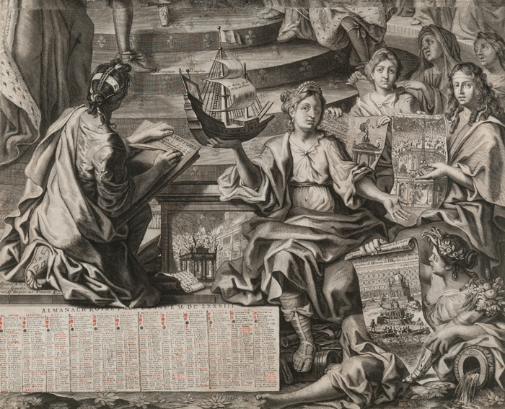
Almanac for the Year 1683 (The Universal Festivities), detail; published by Pierre Landry (c. 1630-1701), Paris; etching, engraving and letterpress on paper; Waddesdon (National Trust); acc. no. 2669.4.3

This is to announce a workshop at Waddesdon Manor in conjunction with the exhibition Glorious Years: French Calendars from Louis XIV to the Revolution. The workshop will explore themes around the production and consumption of French 17th-and 18th-century almanacs (book and print formats), while also looking at the broader context of the history of Time and its depiction during this period. Our distinguished speakers are drawn from across disciplines.
To register an interest in attending please email diane.bellis@nationaltrust.org.uk.
There will be a charge of £25 for the day which covers all catering costs. To secure a place please call the Waddesdon booking office 01296 820414 (open 10:00 – 16:00) to pay using either a debit or credit card.
If you have any dietary requirements please let us know when you book your place.
For more information about the exhibition Glorious Years - https://waddesdon.org.uk/whats-on/glorious-years-exhibition/

Programme
10:00-10:30 Registration + coffee (Manor Restaurant)
10:30-10.50 Welcome and introduction by Pippa Shirley (Head of Collections, Waddesdon) and Rachel Jacobs (Curator, Waddesdon)
10:50-11:20 Maxime Préaud (formerly conservateur général, département des Estampes et de la Photographie, Bibliothèque nationale de France), Les relations entre la France et l'Angleterre pendant le règne de Louis XIV, selon les almanachs muraux français
11:20-11:50 Stephen Boyd Davis (Professor of Design Research, Royal College of Art), La Science des Temps - new ideas of time in the Eighteenth Century
11:50-12:10 Discussion
12:10-13:00 Visit the exhibition Glorious Years with curator Rachel Jacobs and Adam Dant (Artist), The Mother of Parliaments: Annual Division of Revenue: A Print for the British Electorate, 2017
13:00-14:30 Lunch in Manor Restaurant
14:30-15:00 Véronique Sarrazin (Maître de conférence d’histoire modern, Université d'Angers, Laboratoire CERHIO), Livres et estampes, deux économies de l’almanach dans la 1ère moitié du XVIIIe siècle à Paris
15:00-15:30 Matthew Shaw (Librarian of the Institute of Historical Research, School of Advanced Study), Almanacs for a New Era: the French Republican Calendar
15:30-16:00 Discussion
16:00 Drinks with a chance to visit the manor and exhibition (Manor Restaurant)

