Online Seminars | Research Day: ‘The Future of Country House Studies’

From the University of Buckingham:

The Future of Country House studies
Online | Tuesday 13 April 2021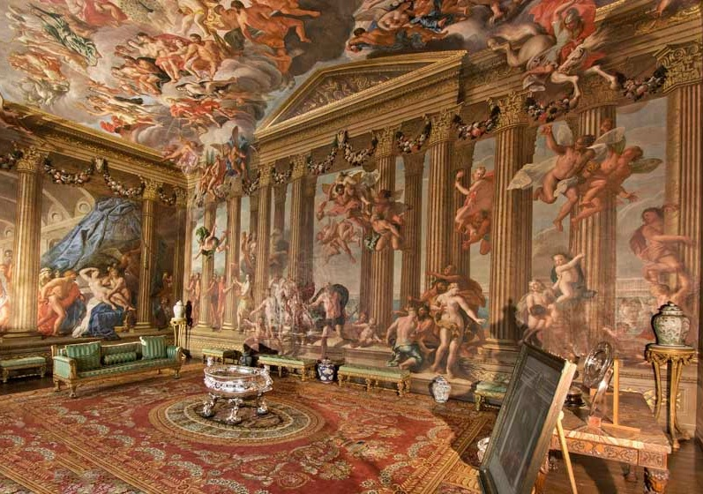

A research day organized by the University of Buckingham Humanities Research Institute – one of a series of research seminars in the history of art.

This series of postgraduate Research Days revolve around some of the main research strengths of the department of History and History of Art of the University of Buckingham: the history of collecting and the evolution of taste; the reception of the classical tradition in the art and architecture of Early-Modern Europe; the cultural history of the long eighteenth century; and the history of materials in art and architecture.

Each Research Day involves presentations by PhD students and members of staff, followed by a seminar given by an established scholar. Their structure is intended to facilitate dialogue and exchange between scholars at different stages of their career.

Tickets: Sessions are open to all, free of charge. Registration in advance, via a simple one-line email, here.

2:30 pm (UK time) Session 1:
Adrian Tinniswood, OBE
Fellow, Humanities Research Institute, University of Buckingham

‘The Guilt and the Gingerbread: The Country House 1945-1974’

Adrian Tinniswood discusses his latest research project, Noble Ambitions, to be published by Jonathan Cape in September 2021. Adrian directs the MA in the History of the English Country House at the University of Buckingham. His most recent books include Behind the Throne: A Domestic History of the Royal Household and The Long Weekend: Life in the English Country House Between the Wars.

3:30 pm (UK time) Session 2:
Michael Bentley
PhD Student, University of Buckingham

‘“Properly bestowed”: Decorum and the Mural in the English Country House,
from Verrio to Thornhill, 1672-1728’

To what extent was decorum a factor in the decision-making process when commissioning wall and ceiling paintings for an English country house? If not decorum, then what? New light will be shed on Adlington Hall, Sudbury Hall and Boughton in particular.

4:30 pm (UK time) Tea break

5:00 pm (UK time) Session 3:
Dr Martin Postle
Deputy Director, Paul Mellon Centre for Studies in British Art, Yale University

‘Collection and Display: Art and the Country House Digital Project’

Martin discusses the Centre’s latest digital project. Art & the Country House, launched in autumn 2020, is an online publication focused on the collection and display of works of art in the country house in Britain from the sixteenth century to the present day. Eight case studies (Castle Howard, Doddington Hall, Mells Manor, Mount Stuart, Petworth House, Raynham Hall, Trewithen and West Wycombe) relate to a broad range of research topics and give a varied set of examples, in terms of geographical location, scale, patterns of ownership, chronologies, collections and displays.

Categories: conferences (to attend), lectures (to attend), online learning

