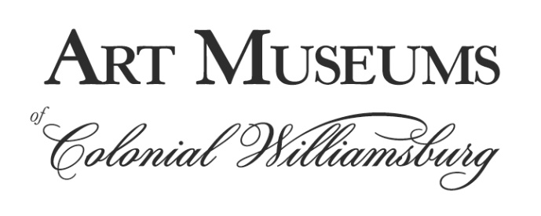
FOR IMMEDIATE RELEASE

Media contacts: Robyn Liverant for the Art Museums of Colonial Williamsburg
212.472.6947 or robyn@robynliverant.com

A GIFT TO THE NATION: THE JOSEPH AND JUNE HENNAGE COLLECTION,
AN EXHIBITION TO HONOR
A LANDMARK AMERICAN DECORATIVE ARTS BEQUEST,
TO OPEN AT THE ART MUSEUMS OF COLONIAL WILLIAMSBURG THIS MONTH

Williamsburg, VA (June 15, 2021)—Earlier this year, the Colonial Williamsburg Foundation announced the most significant single American decorative arts bequest in its 90-year history: The Joseph H. and June S. Hennage Collection with its more than 400 objects of various media including American furniture and miniature furniture, American silver and Chinese porcelain that will transform Colonial Williamsburg’s already renowned collections. To celebrate this momentous bequest, an exhibition of approximately 50 highlighted objects, A Gift to the Nation: The Joseph and June Hennage Collection, will open in the Miodrag and Elizabeth Ridgely Blagojevich Gallery at the DeWitt Wallace Decorative Arts Museum, one of the newly expanded Art Museums of Colonial Williamsburg, on June 26, 2021 and remain on view through 2023. While only a fraction of the overall collection, the items selected for the exhibition will illustrate the Hennages’ exceptional taste and collecting style, the American origins and family histories of the objects and the couple’s passion for American decorative arts.

“Joe and June Hennage were remarkably generous and philanthropic,” said Ronald L. Hurst, the foundation’s Carlisle Humelsine chief curator and vice president for museums, preservation and historic resources. “They wanted to ensure that these exceptional illustrations of the nation’s history and culture would be held in the public trust for everyone’s edification. Their gift to Colonial Williamsburg has done just that and we are forever in their debt.”

“Collectors have many reasons for acquiring the objects they amass, but for the Hennages, who started collecting American decorative arts in the mid-1960s, the first step towards any antique purchase was “buying with your heart,” as June Hennage described it. The next step was studying the object for its authenticity, history and condition to determine if it was right for their collection. This method of consideration led to an assemblage of superlative examples of furniture and silver from important colonial centers including Boston, Philadelphia, New York, Baltimore, Charleston and the Connecticut River Valley. Joe and June only acquired pieces on which they both agreed, and often the items were gifts to one another. Objects were selected both to fit within their home as well as to highlight various forms, such as tables, high chests, chairs, tea sets and sauceboats, which represent the regional diversity in American furniture and silver. These pieces were complemented with an array of other materials, primarily Chinese export porcelain.

Colonial Williamsburg and its annual Antiques Forum played an important role in the Hennages’ collecting focus and philanthropy for more than 50 years; they received the highest honor for service to the foundation, the Churchill Bell award, in 1994. The couple’s patriotic generosity also extended to other institutions to whom they donated important American objects, including the U.S. State Department, the White House, the National Portrait Gallery, Mount Vernon and Monticello.

Objects from the Hennage collection that were selected for this exhibition illustrate June and Joe’s collecting philosophy,” said Tara Chicirda, curator of furniture at the Colonial Williamsburg Foundation. “They specifically acquired representational objects from a variety of regions to highlight the local options in form or ornament, and they often sought out pieces with family histories or by well-known makers with signatures or labels. We have tried to show the breadth and depth of the furniture and silver collections in this exhibition as well as highlight their interest in miniature furniture and Chinese export porcelain.”

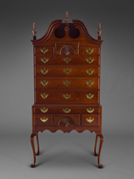
Although each object included in A Gift to the Nation is a highlight of the Hennage Collection, one exceptional piece of furniture is a high chest of drawers possibly made by Isaac Tryon in either Middletown or Glastonbury, Connecticut, located in the fertile Connecticut River Valley, between 1760 and 1790. Joe Hennage gave this piece to June as a gift, and many times over the years, the dealer who sold it to Joe offered to buy it back at a greater price. June declined to sell each time as she felt she would not be able to acquire another Connecticut high chest as nice as this example. Cabinetmakers, such as Isaac Tryon, crafted furniture for the wealthy inhabitants of the Connecticut River Valley, and the vertical, sleek lines and carved fans of this cherry high chest typify the work of makers in this region like Tryon.

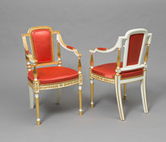
Another highlight to the exhibition is a pair of French-inspired armchairs made in Philadelphia ca. 1790 and believed to have been originally owned by the wealthy Philadelphia merchant and signer of the Declaration of Independence, Robert Morris. French furniture and furniture inspired by French design became quite popular in America after the Revolution, especially in Philadelphia. Following this trend, George and Martha Washington purchased gold and white French chairs for the Presidential House there in 1790. The chairs survive with their original upholstery foundation covered in a reproduction silk of the same color as the show cloth first used.

Joe and June Hennage’s interests in American silver focused primarily on the period between 1730 and 1815 with emphasis in objects from Boston, Philadelphia and Baltimore. Their collection of approximately 100 pieces includes tea and coffee sets, jugs, tankards, cans, goblets, porringers, sauceboats, casters, salvers, punch strainers and ladles, many with known histories of ownership. As with the furniture and ceramics in the bequest of this collection, the silver from the Hennage collection is transforming the already important assemblage of silver in Colonial Williamsburg’s holdings.

“The Hennage silver bequest is game-changing, effectively doubling the number of American-made hollowware pieces owned by Colonial Williamsburg. It offers exciting new opportunities to interpret the diverse range of wares produced by silversmiths from New England to the South and includes important examples with distinguished pedigrees,” said Janine E. Skerry, Colonial Williamsburg’s senior curator of metals.

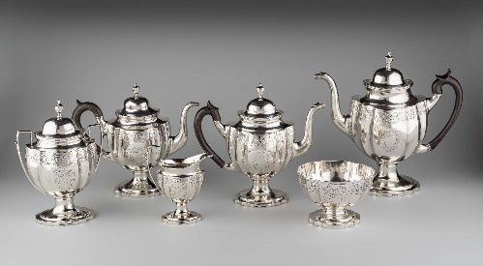
Among the highlights of the Hennage’s silver collection to be on view in A Gift to the Nation is a tea and coffee set by Littleton Holland made in Baltimore, Maryland, ca. 1800. Large en suite tea and coffee sets such as this example became popular by the earliest years of the nineteenth century. This set was made for the Krebs family of Baltimore and features two teapots—one for black tea and one for green—as well as a coffeepot, sugar urn, cream pot and waste bowl. Fashioned in the late neo-classical style with broad fluted panels and bands of bright-cut engraving, this set exemplifies the end of the timeline for the silver that the Hennages collected; very few of their acquisitions date past 1810.

The Chinese export porcelain that Joe and June collected to complement their antique furniture and silver reflected their passion for American history and sense of design. The pieces to be on view in the exhibition include objects with rare American histories of ownership and those that reflect the couple’s love of vibrant color.

“The Chinese porcelain featured in the exhibition not only relays stories of the young United States, but also tells very personal stories of Joe’s and June’s love of collecting and their love of brilliant colors,” said Angelika R. Kuettner, associate curator of ceramics and glass at Colonial Williamsburg. “While the ceramics in this multimedia exhibit are only highlights from the collection, it’s important to note that, to date, the bequest marks the most significant addition to Colonial Williamsburg's collection of Chinese porcelain destined for the post-Revolutionary American market.”

One such example of the Hennages’ love of vibrant color can be seen in A Gift to the Nation through their collection of a hot water dish and plates made in Jingdezhen, China, ca. 1800. These pieces made of hard-paste porcelain represent the variety of colors in which the so-called Fitzhugh pattern was available to eighteenth and early nineteenth century consumers. (Collectors have referred to this diaper and moth or butterfly-bordered four-paneled motif as “Fitzhugh” since at least the late 19th century, and most likely the name derived from Thomas Fitzhugh who served as a British East India Company official from the 1780s until 1800.) The pattern often included a central medallion surrounding a floral sprig or a cypher. Instead of the central medallion, some pieces made specifically for export to the American market feature a splayed eagle holding within its beak a banner bearing the motto “E Pluribus Unum,” all representative of the Great Seal. Vibrant green, orange, yellow and brown as well as the more common underglaze blue version were available and pieces decorated in yellow, such as the Hennages’, are among the rarest examples.

A Gift to the Nation: The Joseph and June Hennage Collection is generously funded by Cynthia Hardin and Robert S. Milligan and Mary Virginia E. and Charles F. Crone in honor of Ronald and Mary Jean Hurst.

For anyone who appreciates the finest of American decorative arts, the Hennage Collection is one for the ages. To have the opportunity to see highlights of this extraordinary assemblage in A Gift to the Nation is one not to be missed.

Additional information about the Art Museums and Colonial Williamsburg as well as tickets are available online at colonialwilliamsburg.org, by calling (855) 296-6627 and by following Colonial Williamsburg on Facebook and @colonialwmsburg on Twitter and Instagram.

About the Art Museums of Colonial Williamsburg
The Art Museums of Colonial Williamsburg include the Abby Aldrich Rockefeller Folk Art Museum and the DeWitt Wallace Decorative Arts Museum, both of which are housed in their newly expanded building that offers an additional 65,000-square-feet of space, 25-percent more gallery space and numerous enhancements to the visitor experience. The Abby Aldrich Rockefeller Folk Art Museum is home to the nation’s premier collection of American folk art, with more than 7,000 folk art objects made up to the present day. The DeWitt Wallace Decorative Arts Museum exhibits the best in British and American fine and decorative arts from 1670–1840. The Art Museums of Colonial Williamsburg are located at 301 South Nassau Street in Williamsburg, Va. Open daily from 9:00 A.M. to 6:00 P.M.

About The Colonial Williamsburg Foundation
Colonial Williamsburg operates the world’s largest living history museum, preserving Virginia’s 18th-century capital as a fully functioning city. Fun, engaging experiences transport guests back in time and highlight the relevance of America’s founding era to contemporary life. The Colonial Williamsburg experience includes more than 600 restored or reconstructed buildings, historic trade shops, renowned museums of decorative arts and folk art, extensive educational outreach programs for students and teachers, lodging, culinary options from historic taverns to casual or elegant dining, the Golden Horseshoe Golf Club featuring 45 holes designed by Robert Trent Jones Sr. and his son Rees Jones, a full-service spa and fitness center managed by Trilogy Spa, pools, retail stores and gardens. Philanthropic support and revenue from admissions, products and hospitality operations sustain Colonial Williamsburg’s educational programs and preservation initiatives. The Colonial Williamsburg Foundation is a 501 (c)(3) nonprofit organization; philanthropic support and revenue from admissions, products and operations sustain its educational programs and preservation initiatives.

# # #

Images: High Chest of Drawers, possibly by Isaac Tryon, Middletown or Glastonbury, Connecticut, 1760-1790, cherry, white pine and tulip poplar, bequest of Mr. and Mrs. Joseph H. Hennage, 1991-62; Armchairs, Philadelphia, Pennsylvania, ca. 1790, ash, gilt, gesso, paint, linen, curled hair, silk, bequest of Mr. and Mrs. Joseph H. Hennage, 2020-170, 1 & 2; Tea and Coffee Set, Littleton Holland, Baltimore, Maryland, ca. 1800, silver, wood, bequest of Mr. and Mrs. Joseph H. Hennage, 2020-249, 1-6; Hot Water Dish and Plates, Jingdezhen, China, ca. 1800, hard-paste porcelain, bequest of Mr. and Mrs. Joseph H. Hennage, (left to right) 2020-197,1; 2020-224; 2020-202,1; 2020-203,1.

