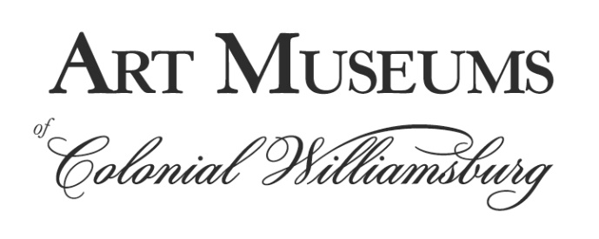

FOR IMMEDIATE RELEASE

Media contacts: Robyn Liverant for the Art Museums of Colonial Williamsburg
212.472.6947 or robyn@robynliverant.com
Ellen Peltz for The Colonial Williamsburg Foundation
757.220.7287 or epeltz@cwf.org

THE SOCIAL HISTORY AND MATERIAL CULTURE OF
EARLY AMERICAN MUSIC,
AS SEEN AND HEARD THROUGH ITS INSTRUMENTS,
WILL DELIGHT VISITORS IN A LANDMARK EXHIBITION OPENING
AT THE ART MUSEUMS OF COLONIAL WILLIAMSBURG IN AUGUST 2022

Williamsburg, Va. (July 11, 2022)—In the 18th century, music was everywhere: in the workplace, the military campsites, the quarters of the enslaved, the church, the theater, the ballroom and the home. Music was an essential part of life that helped foster a sense of community, whether people were accompanying the organ in song at church or enjoying an impromptu concert at home. Making Music in Early America, a new exhibition to open on August 20, 2022, in the Mark M. and Rosemary W. Leckie Gallery at the DeWitt Wallace Decorative Arts Museum, one of the Art Museums of Colonial Williamsburg, will envelop visitors in the musical world of the 18th and 19th centuries.

As told through more than 60 instruments and their accessories, the social history and material culture of early American music will be revealed. This is the first exhibition to show the full scope of Colonial Williamsburg’s musical instruments collection including some pieces that were recently acquired. It is scheduled to remain on view through December 2025. Organized in five sections featuring music in the home, in religion, in education, in public performance and in the military, Making Music in Early America will include harps, organs, violins and other string instruments, fifes, flutes, a bassoon, a grand harmonicon, drums, horns and much more. While the instruments are fascinating in and of themselves, the musicians who played them and their roles in society take center stage in this exhibition.

“Colonial Williamsburg has been collecting early musical instruments for more than 90 years, but we have never before had the opportunity to show the full range of the collection,” said Ronald L. Hurst, the Foundation’s Carlisle H. Humelsine chief curator and vice president for museums, preservation and historic resources. “Supported by examples of original sheet music and paintings of early Americans playing their instruments, this exhibition will place these remarkable objects in their rich, historic context.”

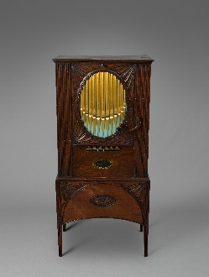
Among the many highlights of Making Music in Early America is a barrel organ, or hand organ, made by Longman, Clementi & Co. in London, England, ca. 1789-1801. It is a hand-cranked organ that could be played inside the home on demand with no musical talent required. The organ barrels operated much like a music box and included dance music, religious music and military marches. They produced music on demand similar to a juke box or record player, if one had the strength to crank the handle and switch out the barrels to change the tunes. In the September 17, 1767, edition of The Virginia Gazette, an item advertising a similar instrument read: “Just Imported from London, a VERY neat HAND ORGAN, in a mahogany case, with a gilt front, which plays sixteen tunes, on two barrels; it has four stops, and every thing is in the best order. The first cost as 16£ sterling, and the Lady being dead it came in for, any person inclining to purchase it may have it on very reasonable terms. Inquire at the Post Office, Williamsburg.”

“This incredibly diverse collection of musical instruments offers us ways to tell the stories of the people who lived here during the 18th and early 19th centuries by examining who interacted with these instruments and why,” said Amanda C. Keller, Colonial Williamsburg’s manager of historic interiors and associate curator of household accessories who organized this exhibition. “The instruments become even more fascinating when you discover who played them and what role music played in society.”

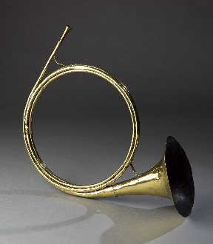
One of the earliest hunting horns known in American collections is another featured object in the exhibition. Simple hunting horns were being made in the American colonies as early as 1765, but the majority were imported from Europe like this brass horn, made by Johannes Leichamschneider in Vienna, Austria, ca. 1715. As hunting horns were worn by the rider, they were easily battered. As a result, early hunting horns rarely survived, and this is an outstanding example that scholars come to The Colonial Williamsburg Foundation to study. Although the horn section may have been modified over time and updated, the bell is original. Only one other just like this example survives with a history of use at Mount Vernon. It is recorded that George Washington’s enslaved valet, William Lee, performed the important duties of Huntsman, tending to the horses and hounds, as well as blowing the hunting horn during fox hunts at Mount Vernon and other estates. Although the history of Colonial Williamsburg’s hunting horn is unknown, it illustrates the once-prominent role played by free and enslaved huntsmen in the early South.

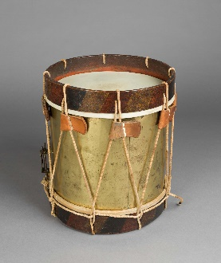
Revolutionary War military instruments are especially rare, and this brass “Hessian” drum, from the Frebershausen area in the Hesse-Kassel region of what is now Germany, ca. 1770-1785, is another featured object to be on view in Making Music in Early America. It was brought over by one of the many so-called Hessian units hired by the British to fight in the American Revolution and was most likely captured by American forces. Made of brass, this drum still has some secrets to reveal: Colonial Williamsburg’s experts, with the aid of colleagues across the Atlantic, are researching to which regiment it belonged and are using the painted colors around the top and bottom bands to help solve its mystery.

Also included in the exhibition will be ways for visitors to be able to hear the sounds of four of the instruments (banjo, harpsichord, organized piano and musical glasses) as well as an opportunity to see a musician play an organized piano (the period term indicating the addition of several organ stops playable from the same keyboard). Additionally, guests will be able to use an interactive touch screen to view an extraordinary music book in the Colonial Williamsburg collection that was owned by Peter Pelham (1721-1805), an English-born American organist, harpsichordist, teacher and composer. Born in London, Pelham and his family immigrated to Boston in 1730. While there, Pelham’s father apprenticed him to Charles Theodore Pachelbel, son of composer Johann Pachelbel who is known for “Canon in D,” which is still popular today. Pelham followed Pachelbel to Charleston in 1736, and remained there for a number of years, studying with Pachelbel and later becoming a harpsichord teacher himself. Pelham returned to Boston in 1744 to serve as the first organist of Trinity Church. In 1750 Pelham moved to Williamsburg, to serve as organist at Bruton Parish Church. While in Williamsburg Pelham actively participated in the city’s musical life, giving concerts and teaching young ladies to play the spinet and harpsichord. Additionally, he supported himself and his family by serving as clerk to the royal governor, supervisor of the printing of money, and keeper of the Public Gaol. The music book that will be on view includes music that Pelham enjoyed as well as some of his original compositions. It has never been on view before, and although the original book is too fragile to be placed on view, this digital interactive will allow visitors to page through the book and see the music for themselves.

Making Music in Early America is generously funded by an anonymous donor.

For music enthusiasts, cultural historians and anyone fascinated by colonial life of all ages, Making Music in Early America is an exhibition not to be missed.

Following the guidance of the Centers for Disease Control and Prevention (CDC) issued Feb. 25, Colonial Williamsburg no longer requires guests to wear masks during their visit. The foundation’s latest COVID-19 health and safety policies are available at colonialwilliamsburg.org.

Additional information about the Art Museums and Colonial Williamsburg as well as tickets are available online at colonialwilliamsburg.org, by calling (855) 296-6627 and by following Colonial Williamsburg on Facebook and @colonialwmsburg on Twitter and Instagram.

About the Art Museums of Colonial Williamsburg
The Art Museums of Colonial Williamsburg include the Abby Aldrich Rockefeller Folk Art Museum and the DeWitt Wallace Decorative Arts Museum, both of which are housed in their newly expanded building that offers an additional 65,000-square-feet of space, 25-percent more gallery space and numerous enhancements to the visitor experience. The Abby Aldrich Rockefeller Folk Art Museum is home to the nation’s premier collection of American folk art, with more than 7,000 folk art objects made up to the present day. The DeWitt Wallace Decorative Arts Museum exhibits the best in British and American fine and decorative arts from 1670–1840. The Art Museums of Colonial Williamsburg are located at 301 South Nassau Street in Williamsburg, Va. Open daily from 10:00 A.M. to 6:00 P.M.

About The Colonial Williamsburg Foundation
Colonial Williamsburg operates the world’s largest living history museum, preserving Virginia’s 18th-century capital as a fully functioning city. Fun, engaging experiences transport guests back in time and highlight the relevance of America’s founding era to contemporary life. The Colonial Williamsburg experience includes more than 600 restored or reconstructed buildings, historic trade shops, renowned museums of decorative arts and folk art, extensive educational outreach programs for students and teachers, lodging, culinary options from historic taverns to casual or elegant dining, the Golden Horseshoe Golf Club featuring 45 holes designed by Robert Trent Jones Sr. and his son Rees Jones, a full-service spa and fitness center managed by Trilogy Spa, pools, retail stores and gardens. The Colonial Williamsburg Foundation is a 501 (c)(3) nonprofit organization; philanthropic support and revenue from admissions, products and operations sustain its educational programs and preservation initiatives.

# # #

Images: Barrel Organ, Clementi & Co., London, England, 1805-1820, mahogany, oak and deal framework and interior supports, iron and brass hardware, wood barrels with brass pins, Gift of Mr. and Mrs. Harry V. Long, 1933-487; Hunting Horn, Johannes Leichamschneider, Vienna, Austria, ca. 1715, brass, Museum Purchase, 1951-456; Hessian Drum, Freberschausen, Waldeck region, Germany, ca. 1770-1785, wood, skin, copper alloy, Museum Purchase, 1957-29.

