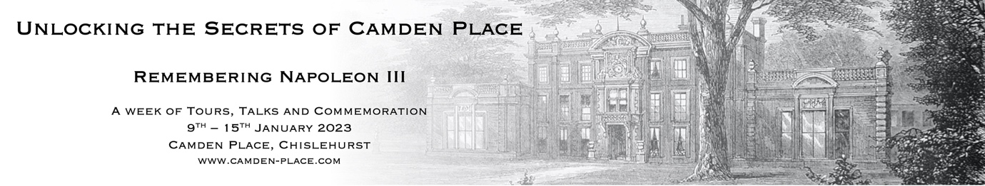

CALL FOR PAPERS

Boiseries: Decoration and Migration from the Eighteenth Century to the Present

Thursday 12th & Friday 13th January 2023
Camden Place, Chislehurst (Kent)

Deadline: Friday 2 September 2022

This conference investigates the cultural and commercial migrations of French eighteenth-century boiseries from their places of production in Paris and the Bâtiments du Roi to the drawing rooms of Britain and the United States.

From an historical perspective boiseries have always, in a sense, been mobile. In the eighteenth century, Paris joiners and carvers travelled to locations outside the city to install panelling, and entire decorative schemes were sent abroad to Germany, Spain, and Latin America. Accompanied by mirrors and tapestries from royal manufactories, these panels disseminated French style in accordance with the diplomacy of the monarch and the desires of foreign courts. Boiseries executed for particular sites but not installed were also sometimes reused elsewhere: failed deliveries and changes in taste during the period from commission to installation occasioned opportunities for buyers, and sets of panelling conceived as complete ensembles were broken up and dispersed for use in multiple locations, or disused altogether. Shifting fashions and continual reallocations of appartements at Versailles set into motion near-ceaseless rotations of décors, including boiseries. And, notwithstanding the legal categorisations of panels, once fixed, as immeubles, removals were negotiated by tenants during their lease of, and on their departure from, urban hôtels.

In the nineteenth century, the pace and directionality of movement changed, as elements of interior decoration began to be acquired for their own merit and eighteenth-century boiseries became the relics of a physically and culturally disappearing French national history as well as the trophies of an international collecting elite. Elements of woodwork, disassembled from demolished châteaux or reproduced in survey drawings and plaster casts, made their way into rooms in Britain and the United States, their proportions and ornament amplified and metamorphosed – to borrow terms used by John Harris and Bruno Pons – to match the pitch of the French Second Empire and later living. Professional interior decorators and commercial dealers in decorative arts were largely to credit, providing channels by which goods could easily be transported from place to place. However, boiseries also emigrated, as it were, with exiles of the Republic, extending the presence of French style to less-cosmopolitan regions and adding geopolitical to social and architectural concerns.
Camden Place, where the conference will be held, is an English country house whose history and interiors have been shaped by the migration of people and decoration for over 300 years. Home to Chislehurst Golf Club, the Grade II* listed building features architectural elements by the British architects George Dance the Younger (1741–1825) and James ‘Athenian’ Stuart (1713–1788), and played host to the French Imperial court after the fall of the Empire in 1870. French chimney pieces, boiseries from the eighteenth-century Château de Bercy (demolished in 1862), and heavily carved oak panelling are among the elements that make up the house’s many layers, testifying both to the eclectic tastes of its nineteenth-century occupants and to the multifaceted, and multinational, histories of many English country houses.
This conference provides a unique opportunity for cultural historians of France, art and architectural historians, historians of collecting, curators, and heritage professionals to meet in a room reassembled following the landmark Château de Bercy sale (1860) and to meditate on the finer points of its significance in the dispersal of French cultural patrimony.
The organisers invite abstracts for 20-minute papers on topics engaging with, but not limited to:
- The relative mobility (meubles/immeubles) of boiseries in the 18th century
- Collecting, architectural salvage, and markets for boiseries in the 19th and 20th centuries
- Exchanges of taste and culture as a result of political displacement, in particular the influence of French émigrés
- Memory and the material traces of Empire
- Documentary and curatorial challenges posed by collections of boiseries
- The management of architectural heritage in private and commercial spaces today
Confirmed speakers include Dr Lee Prosser (Historic Royal Palaces), Frédéric Dassas (Musée du Louvre), Dr Ulrich Leben (German Ambassador’s residence, Paris), Dr Mathieu Deldicque (Musée Condé, Château de Chantilly), and Dr Tom Stammers (University of Durham).
Some funds will be available to support travel and accommodation for speakers. The conference is generously supported by the University of Buckingham, The Chislehurst Society, and Chislehurst Golf Club as part of a programme of events marking the 150th anniversary of the death of Napoleon III at Camden Place.
Submissions for 20-minute papers (300 words) should be sent to lindsay.macnaughton@buckingham.ac.uk and laura.jenkins@courtauld.ac.uk by Friday 2 September 2022. We look forward to receiving your abstracts.
With thanks from the organisers: Dr Lindsay Macnaughton (University of Buckingham) and Laura C. Jenkins (The Courtauld Institute of Art).
For more information, please visit: boiseriescamdenplace.wordpress.com (coming soon).



