Call For Papers

Rococo Across Borders: Designers and Makers

A Symposium organized by the Furniture History Society and the French Porcelain Society

24 and 25 March 2023, London [Venue TBC]

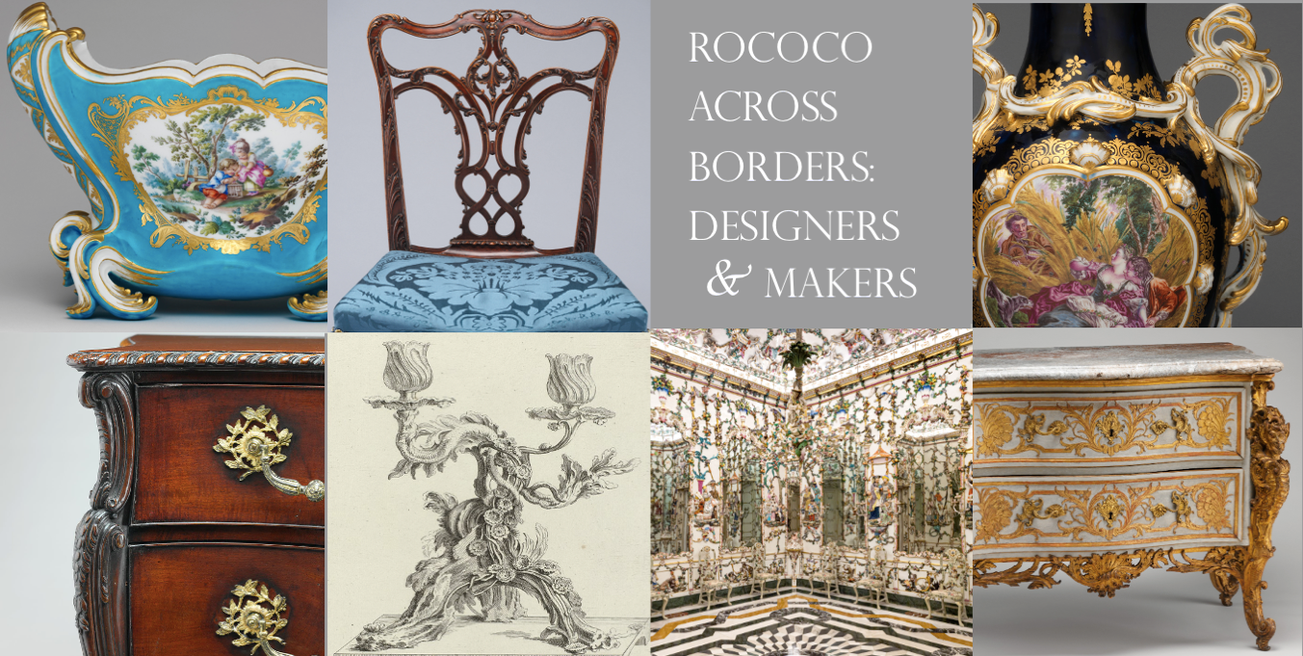

We are delighted to announce that the Furniture History Society and the French Porcelain Society will be joining forces in Spring 2023 to hold a two-day symposium on the theme of ‘Rococo Across Borders: Designers and Makers’.

Using the Versailles exhibition, Louis XV, Passion d’un roi / Louis XV, Passions of a King, as our starting point, the symposium will broaden out to discuss the geographical spread of the style, the interaction between designers and makers, and the significant roles played by print culture and the evolving art market in disseminating the Rococo across Europe.

This symposium calls for papers that go beyond the traditional geographical, chronological and conceptual fields of Rococo design to explore how it evolved throughout the eighteenth and nineteenth centuries. In particular, it aims to open up wider discussions about the historical contexts for Rococo ceramics and furniture, the place of the ‘Rococo’ in museums and art historical scholarship today, and its impact on contemporary makers.

We invite submissions for 30-minute conference papers. Topics for consideration may include, but are not limited to the following:
- ‘Beyond Rococo’: Ceramics, furniture and decorative schemes outside France
- Networks: Makers, designers and consumers across borders
- Case studies of individual interiors or objects
- Changing reception: scholastic and the art market
Deadline: Friday 4 November 2022
Please submit an abstract of 250-300 words and a short biography to: diana_davis@hotmail.co.uk and events@furniturehistorysociety.org

Organizing Committee:
Dr Diana Davis, Patricia Ferguson, Beatrice Goddard, Dr Caroline McCaffrey-Howarth, David Oakey, Adriana Turpin.

Please e-mail events@furniturehistorysociety.org with any queries.

https://www.thefrenchporcelainsociety.com

https://www.furniturehistorysociety.org

Picture Credits: Top left to bottom right, Flower vase (cuvette Mahon), probably designed by Jean-Claude Duplessis, Sèvres Manufactory, French, soft-paste porcelain, c. 1757–60, Metropolitan Museum of Art, 1974.356.592; Side chair, attributed to Benjamin Randolph, Philadelphia, Pennsylvania, American, mahogany, c. 1769, Metropolitan Museum of Art, 1974.325; Vase, Chelsea factory, British, soft-paste porcelain, c. 1762, Metropolitan Museum of Art, 1970.313.2a; Commode attributed to William Vile and John Cobb, mahogany, pine, gilt-bronze, British, c. 1760, Metropolitan Museum of Art, 64.101.1142; Girandolle à branche de porcelaine garnie d’Or, from Oeuvres de Juste-Aurèle Meissonnier, engraved by Gabriel Huquier, French, 1738-49, Cooper-Hewitt, Smithsonian Design Museum, 1921-6-212-29-b; Porcelain Room designed by Giuseppe Gricci, Real Fábrica de Porcelana del Buen Retiro, installed in the Palace of Aranjuez, Spanish, 1763-5; Commode designed by Jean-François Cuvilliés, the Elder, pine partially painted and gilded, German, c. 1735-40, Metropolitan Museum of Art, 28.154.

