
For immediate release, December 12, 2022:
DECORATIVE ARTS TRUST ANNOUNCES 2023 FAILEY GRANTS
– Grants Awarded to British and Irish Furniture Makers Online,
The Center for Painted Wall Preservation, Preservation Long Island, and Stenton –

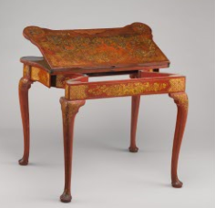
The British and Irish Furniture Makers Online (BIFMO) project researches makers such as Giles Grendey, whose 1735–40 card table is in The Metropolitan Museum of Art’s collection. (Lacquered and gilded beech, lined with felt. Gift of Louis J. Boury, 1937, 37.114.)

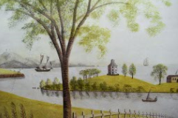
Detail of Rufus Porter's mural, likely early 1830s, in the Andrews House in West Boxford, MA. Distemper paint on plaster. Courtesy the Center for Painted Wall Preservation.

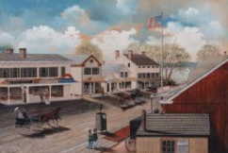
Edward Lange, Lower Main Street, Northport, 1880. Watercolor, gouache, and lead pencil on paper. Collection of Preservation Long Island, 2011.2.

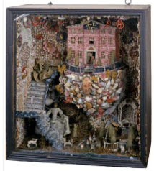
Anne Reckless Emlen, Shellwork grotto, 1757, Philadelphia. The National Society of The Colonial Dames of America in the Commonwealth of Pennsylvania, Stenton.
Media, PA – The Decorative Arts Trust announced that the 2023 Dean F. Failey Grant recipients will be British and Irish Furniture Makers Online (BIFMO) in London, England; The Center for Painted Wall Preservation (CPWP) in Hallowell, ME; Preservation Long Island (PLI) in Cold Spring Harbor, NY; and Stenton in Philadelphia, PA.
The Failey Grant program provides support for noteworthy research, exhibition, publication, and conservation projects through the Dean F. Failey Fund, named in honor of the Trust’s late Governor. Preference is given to projects that employ or are led by emerging professionals in the museum field.
BIFMO will hire interns to research immigrant tradespeople in New York City, Philadelphia, Annapolis, and Baltimore under the guidance of BIFMO Managing Editor Dr Laurie Lindey, Digital Editor Jonathan Blaney, and BIFMO Project Manager Adriana Turpin.
CPWP will develop a virtual museum of historic painted interiors under the direction of Project Coordinators Margaret Gaertner and Linda Carter Lefko.
PLI will produce the book Promoting Long Island: The Art of Edward Lange, 1870-1889, edited by PLI Curator Lauren Brincat and PLI Curatorial Fellow Peter Fedoryk with essays from these editors as well as Jennifer L. Anderson, Thomas Busciglio-Ritter, Sarah Kautz, and Joshua Ruff.
Stenton, a historic house museum administered by The National Society of The Colonial Dames of America in the Commonwealth of Pennsylvania, will conserve a 1757 shellwork grotto by Anne Reckless Emlen, led by Stenton Curator Laura Keim, Stenton Curatorial Assistant Kaila Temple, and Conservator Lara Kaplan.
Failey Grant applications are due October 31 annually. For more information, visit decorativeartstrust.org/failey or call 610.627.4970.

# # #

For more information, contact:
Matthew Thurlow, Executive Director
thetrust@decorativeartstrust.org, 610.627.4970

