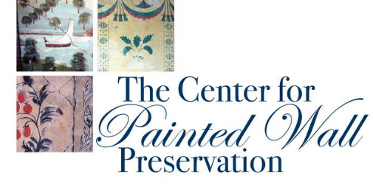

THE CENTER FOR PAINTED WALL PRESERVATION

IS PROUD TO ANNOUNCE
THE 2026
CENTER FOR PAINTED WALL PRESERVATION SCHOLARSHIP

The Center for Painted Wall Preservation (pwpcenter.org) invites undergraduate and
graduate students, independent scholars, and artisans, whether established or in training, to apply for this scholarship, which aims to develop educational projects that further our mission through documentation, conservation, and preservation – where art, history, craft, and science meet.

Applications are accepted beginning January 1, 2026, through midnight April 30, 2026. This year's Scholarship of $2000 will be awarded to the individual whose proposal for an educational, scholarly project is deemed best designed to further the stated mission of our organization — to further the study, understanding, and appreciation of paint-decorated plaster walls and associated interior colorized items of the 18th and early 19th centuries in New England and New York, and to educate the public about this unique and vulnerable cultural heritage.

Interested parties may apply for an Application Process Summary and Application Form by contacting info@pwpcenter.org with Scholarship Fund in the subject line.

From the Scholarship Committee,
The Center for Painted Wall Preservation –
A nationally recognized 501(c)(3) Nonprofit Organization
